Taipei Medical University
Master Program in School of Nursing
Master Thesis

Advisor: Tsai-Wei Huang
Co-Advisor: Haryani Haryani

Thesis Title Thesis Title Thesis Title

Student’s Name: WINNER WINNER

July 2023

Taipei Medical University
Master Program in School of Nursing
Master Thesis

Thesis Title Thesis Title Thesis Title

Advisor:
Co-Advisor:

Student’s Name: WINNER WINNER

July 2023
Agreement of Master Thesis Printing

This thesis of WINNER WINNER which had been reviewed by committees, and revised the manuscript as the committees’ suggestions. I agree the graduate to print this manuscript.

Advisor: ＿＿＿＿＿＿＿
Date: ＿＿＿＿＿＿＿
(YYYY/MM/DD)

Abstract

Title of Thesis:

Institution: Master Program, School of Nursing, Taipei Medical University

Author:

Thesis Advisor: (Name & Title)

Table of Content
 |  |  | Pages
Acknowledgements | ........................................................... |  | Ⅰ
Abstract | ........................................................ |  | Ⅱ
Table of Content | ........................................................ |  | Ⅲ
List of Figures and Tables | ........................................................ |  | Ⅳ
List of Figures | ........................................................ |  | Ⅳ
List of Tables | ........................................................ |  | V
Chapter I Introduction
○○○○○ | ........................................................... |  | 1
Chapter II Literature Review
○○○○○ | ........................................................... |  | 7
Chapter III Methodology
○○○○○ | ........................................................... |  | 20
Chapter IV Results
○○○○○ | ........................................................... |  | 25
Chapter V Discussions
○○○○○ | ........................................................... |  | 35
Chapter VI Conclusions
○○○○○ | ........................................................... |  | 40
References | ........................................................... |  | 53
Appendices
Appendix 1 | ........................................................... |  | 56

List of Figures and Tables

List of Figures

List of Tables

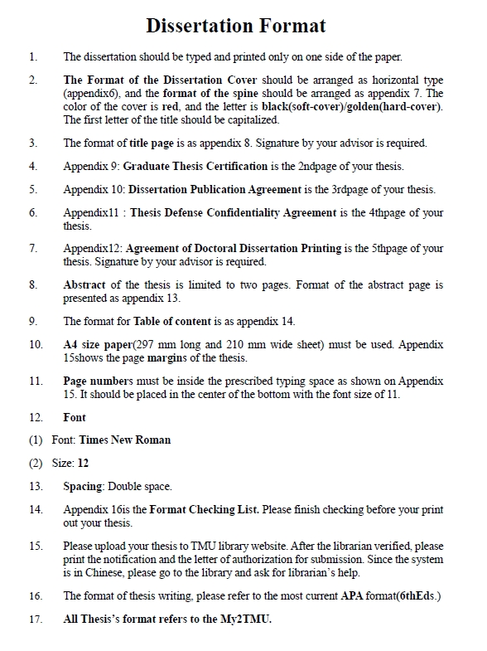
-1-
1.5cm (Having the page number)

13cm

.2.5cm

5cm

2.5cm

3cm（no page number）

13cm

.2.5cm

5cm
3cm

13cm

.2.5cm

5cm
2.5cm

1.5cm (Having the page number)

13cm

.2.5cm

5cm
Appendix 8

